MAI Agentic AI Masterclass · Week 5 group project
Crisis Coach
Scenario walkthrough
Four incidents, walked end to end. Every one of the thirty required features shown at the moment it is actually used - what the user says, what the agent says back, and what happens when the user does not follow the script.

How this document pairs with Functions and Features
That document | This document
Lists all 30 required features, grouped A to F, one line each. | Shows each of those 30 in a real conversation, with the exact words.
Answers: what does the product do? | Answers: what does it sound like, and what happens when it goes wrong?
Feature numbers 1 to 30 are the shared key. | Every row here carries the same feature number. The matrix at the end maps all 30 back.

FOR SUCHITRA Sections 6 and 7 are written for you. Section 6 is every off-script path we know of; section 7 is the voice and tone rules. Everything before them is context so those two make sense.

1 The whole product on one page
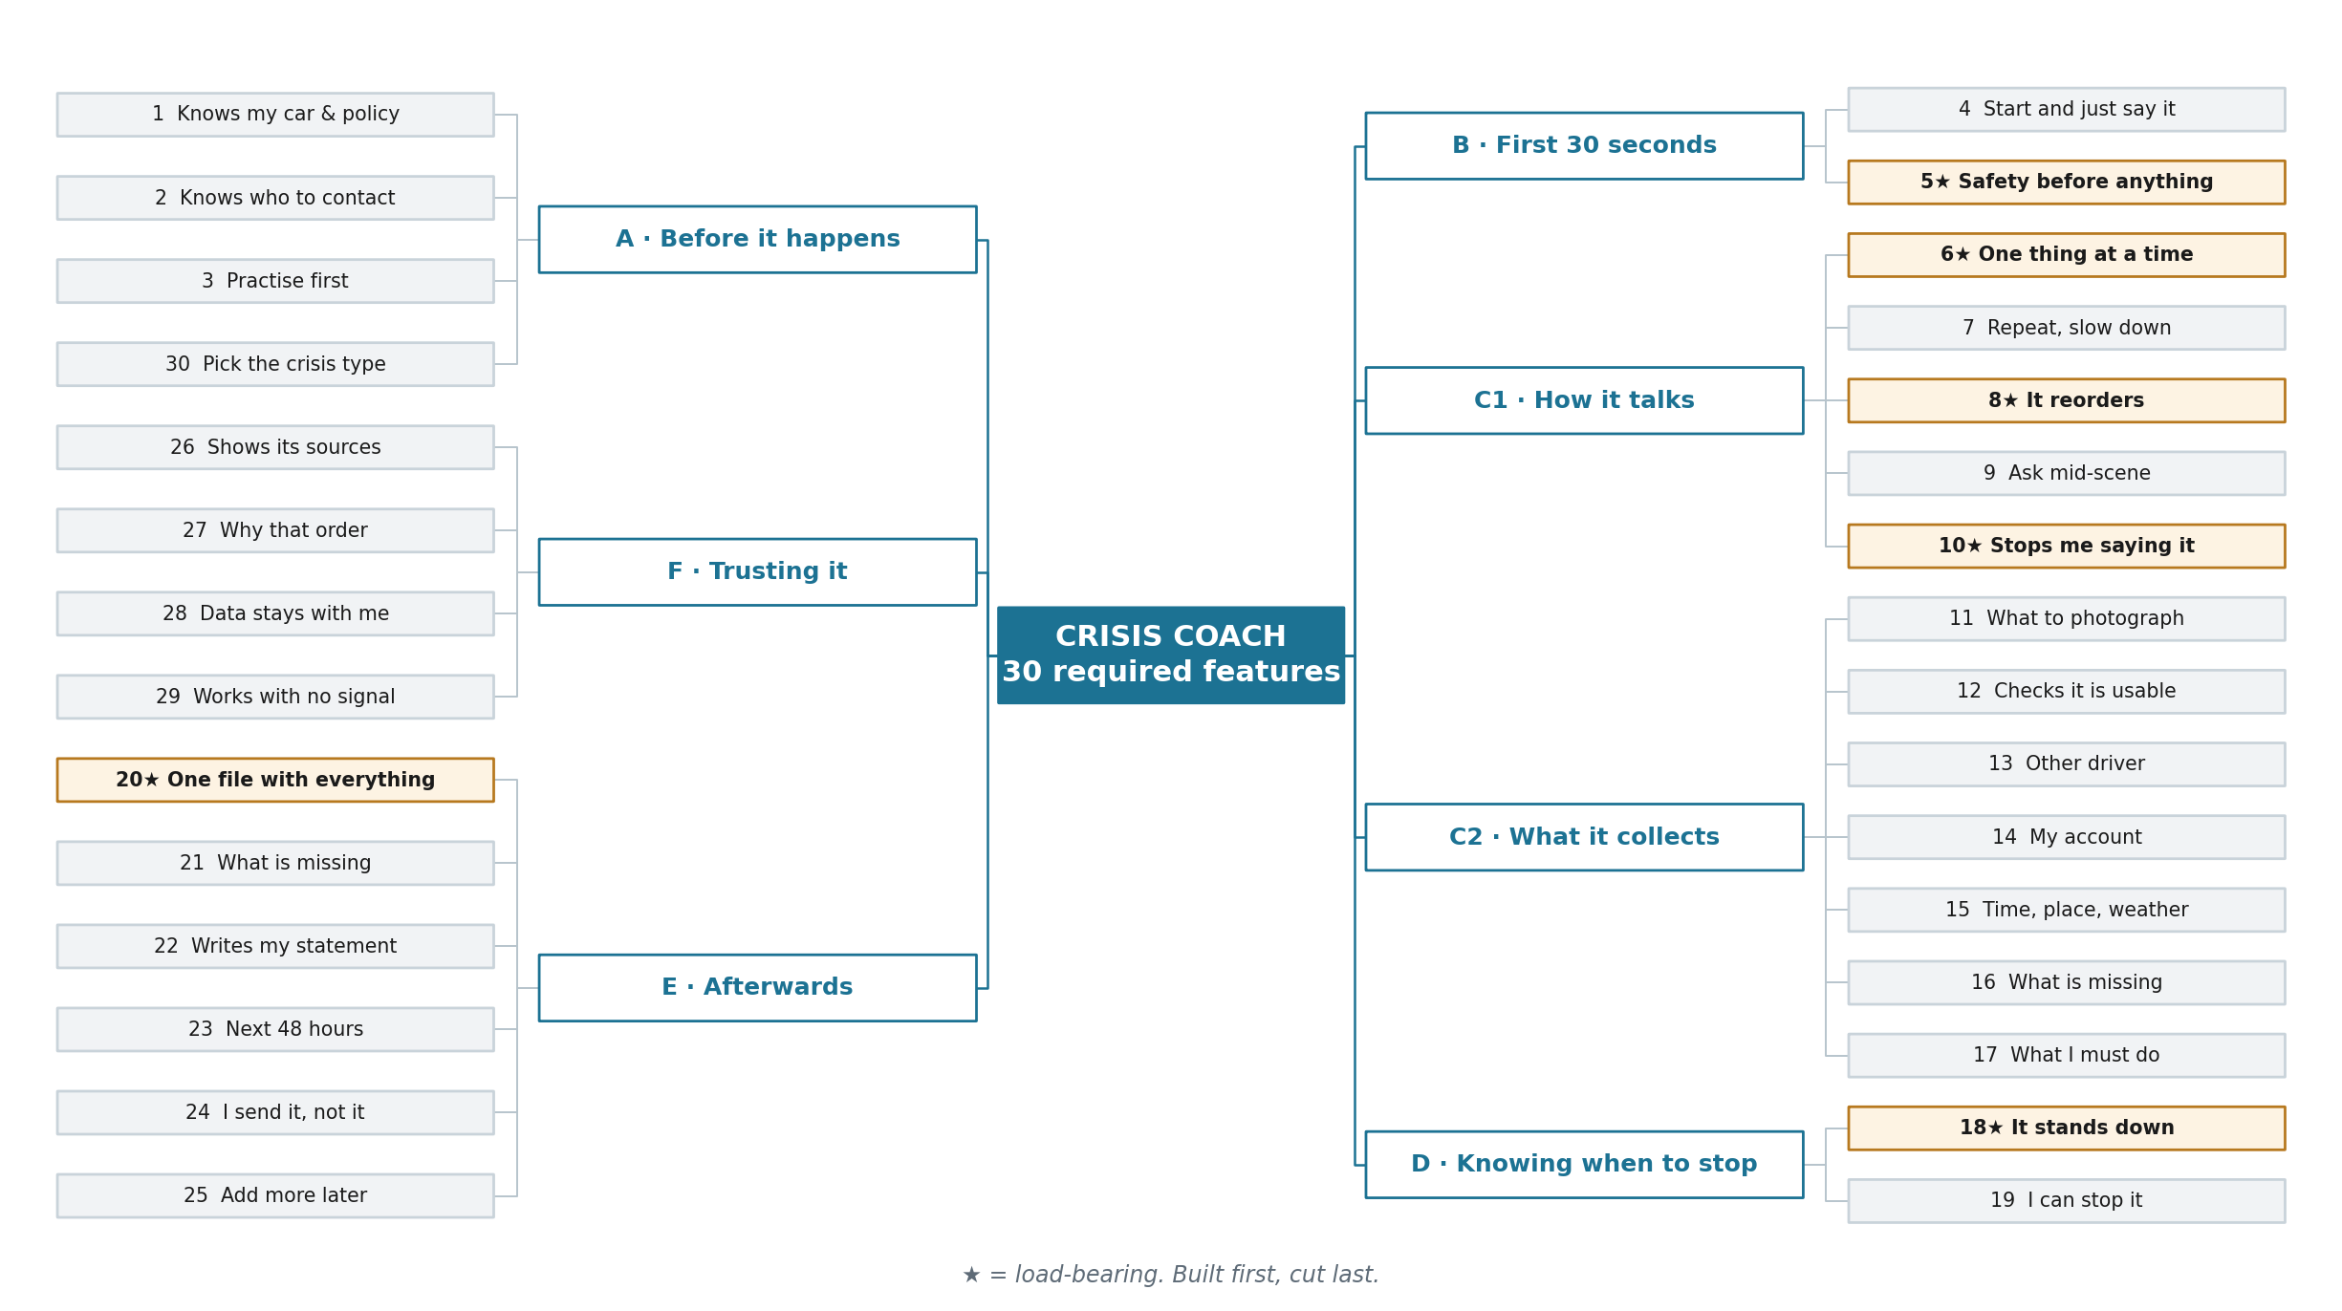
All 30 required features. ★ marks the six that are built first and cut last.

2 The four scenarios
# | Who | What happens | Why it is here
S1 | Priya Raman | Rear-ended at a car park exit. Other driver present, apologetic, a witness about to leave. | The full path. Most features live here.
S2 | Marcus Bell | Comes back to his parked car. Deep scrape, no note, nobody there. | No other party at all. A completely different conversation.
S3 | Dana Okoye | Ring road collision. She says her chest hurts. | The stand-down. Thirty seconds long, and the most important.
S4 | Priya again | Three weeks later, scrapes a bollard. $300 of damage. | The agent tells her not to claim. Restraint as a feature.

3 Scenario 1 · Priya · the full path
Who | Priya Raman, 38. 2021 Honda CR-V. Never been in a collision.
Cover | Meridian Mutual. $500 excess, protected no-claims, 24-hour notification clause she has never read.
When | Tuesday 8 September, 19:42. Dark, raining.
Where | Exit ramp of a shopping centre car park. Private land - which matters, and she does not know it.
Him | Frank Doyle, 71. Shaken, apologetic. Suggests they leave the insurers out of it.
Also there | A woman in a blue coat saw it, and is walking to her car.

Safety | › | Secure the scene | › | What is vanishing | › | Details | › | Statement | › | Close

3.1 Before it ever happens
# | Priya does | Crisis Coach says
1 | Photographs her policy and registration, months earlier. | “2021 Honda CR-V. Meridian Mutual, $500 excess. One thing to know: they need to hear about any incident within 24 hours.”
2 | Adds her husband Dev as her contact. | “I will not contact Dev unless you tell me to.”
3 | Taps Practise. Three minutes, a made-up bump. | “That is roughly how it will go. You will not have to remember any of it.”
30 | Sees the crisis types on the home screen. | Collision · Medical · Workplace · Home. She picks nothing today.

3.2 The scene, minute by minute
T+ | Priya | Crisis Coach | #
0:04 | “Something's happened. Someone hit me.” | “I'm here. First - are you hurt anywhere?” | 4, 5★
0:09 | “No. Shaken, but fine.” | “Is anyone else hurt? The other driver, a passenger, anyone on foot?” | 5★
0:14 | “No, he's out of his car, he looks okay.” | “Good. Are you somewhere safe to stand?” | 5★
0:20 | “Yes, I'm on the kerb.” | “Photograph both cars exactly where they are, before anyone moves them. Stand back about ten feet, both cars and the gap between them in one shot.” | 6★, 11
1:02 | [photographs the plate] | “The plate is blurred - too dark. Closer, and hold still for a second.” | 12
1:20 | “He says we should just swap details and not involve insurers.” | “Don't agree to that yet. And do not apologise - it is not politeness here, it is an admission. Say: are you hurt? Let's exchange details and let the insurers sort it out.” | 10★
1:38 | “Sorry - say that last part again?” | “Say: are you hurt? Let's exchange details and let the insurers sort it out.” | 7
2:05 | “There's a woman who saw it. She's walking off.” | “Stop what you're doing. Get her name and a phone number now. A witness is the one thing you cannot get back afterwards.” | 8★
2:40 | “Got her. Maya Chen, and a mobile.” | “Good. Back to him - name, licence, insurance card. Photograph them if he will let you.” | 8★, 13
3:30 | “He's getting back into his car.” | “Then his plate and the front of his car, right now. Skip the wide shot, I have it. If his insurance card is in your hand, photograph it before he takes it back.” | 8★
4:10 | “Do I need to call the police for this?” | “You're on private land, so city police usually won't attend. Call the centre's security office - they hold the CCTV, and it is only kept a few days.” | 9, 17
5:20 | “What's left?” | “Three things. Close-ups of your own damage, one shot up the ramp showing what you could see, and thirty seconds telling me what happened.” | 16
6:00 | “It was raining, I was waiting to turn right...” | “Got it, in your words. I have also logged the time, the place and the rain - which matters if anyone later says visibility was fine.” | 14, 15
6:40 | “Hold on. Stop.” | “Stopped. Say go on whenever you're ready.” | 19

3.3 What happened at 3:30
The moment that separates this from a printed checklist. He moves toward his car; the whole plan reprices in one turn.
Plan before · T+3:20 | Plan after · “He's getting back in his car”
1. Wide shot of both cars  2. His damage, his side  3. Licence and insurance card  4. Her own damage  5. Sight lines up the ramp  Nothing urgent. Everything reachable. | 1. His plate gone in ~60s  2. His insurance card gone in ~60s  3. Front of his car  4. Her own damage  5. Sight lines up the ramp  Wide shot already captured - dropped.

3.4 Afterwards, in the car
# | Priya | Crisis Coach
20★ | “What have we got?” | One file: 11 photographs, Frank Doyle's details, Maya Chen's number, her statement, the time, the place, the weather, the security desk reference.
21 | “Is anything missing?” | “Two things. His damage from his side - he drove off first. And the centre's CCTV, which you can still request, but only for about seven days.”
22 | “Do I have to write this up?” | “No. Here is your statement, in your words. Read it and change anything wrong.”
23 | “What do I actually have to do now?” | “Tell Meridian before 19:42 tomorrow. Don't accept a cash offer from him directly. Expect an adjuster within two working days.”
24 | “Send it to Meridian.” | “Ready to send 11 photographs and your statement. Nothing has left your phone yet. Send it?” [ she taps yes ]
25 | Next Tuesday: “Add the body shop estimate.” | “Added to the same file. Your claim reference is already on it.”
26 | “How do you know I only have 24 hours?” | “Your Meridian policy, section 7.2.” - and shows her the paragraph.
27 | “Why did you jump to the witness?” | “She was about to leave. Her details were worth 5 out of 5 and I had about a minute. The wide shot was worth 4 and going nowhere.”
28 | “Where has all this been sitting?” | “On your phone. Nothing left it until you pressed send.”
29 | In the basement, no signal. | Kept working from what it had, and queued the send for when she surfaced.

4 Decision trees

4.1 The safety gate · features 5★ and 18★
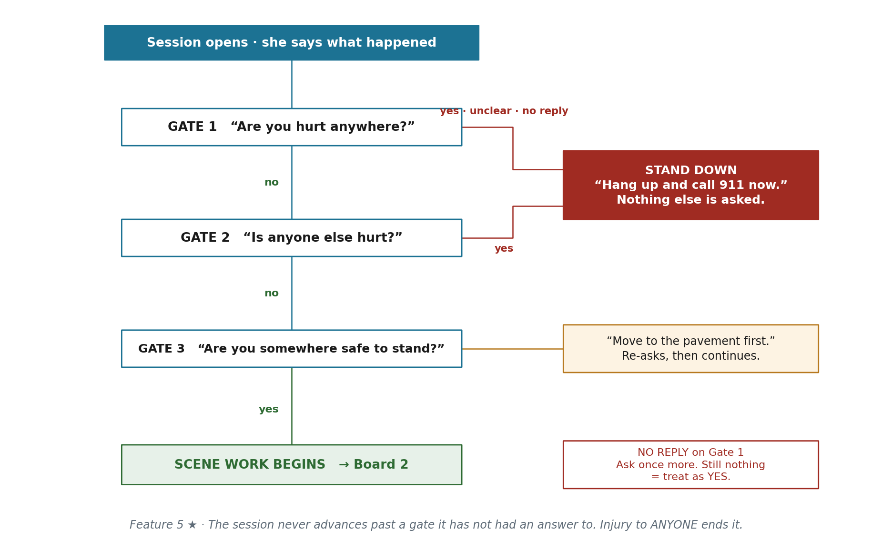
Three gates. The session never advances past one it has not had an answer to.

5 Scenario 2 · Marcus · nobody there
Who | Marcus Bell, 44. Drives a 2019 Ford Focus.
When | Thursday, 19:10. Supermarket car park.
What | He comes back to his car. Deep scrape down the driver's side, wing mirror hanging. No note. Nobody around.
Why it matters | There is no other party to get details from. The whole job becomes proving it happened here, before the evidence of that disappears too.

T+ | Marcus | Crisis Coach | #
0:05 | “Someone's hit my car and driven off.” | “Were you in it? Are you hurt?” | 5★
0:10 | “No, I just came back to it.” | “Then nothing is urgent for your safety. But two things are disappearing right now - the CCTV and anyone who saw it. We do those first.” | 6★, 8★
0:25 | “Alright.” | “Photograph the damage, then the bay you're parked in. I need the bay number and the pillar marking in one shot.” | 11
1:10 | “Done. There's a camera on the wall.” | “Photograph the camera and which way it points. Then go to the service desk and ask them to preserve the footage for a hit and run. They usually hold it about seven days.” | 11, 17
2:00 | “Should I call the police?” | “Yes - for this one you need to. A hit and run with no other driver needs a police report number, or your insurer will treat it as an at-fault claim against your own policy.” | 9, 17
3:00 | “Nobody saw anything.” | “Ask the two cars either side whether they have a dashcam. Most people say yes and had forgotten they had one.” | 8★
4:00 | “What's missing?” | “The other vehicle entirely. Without the CCTV or a dashcam this stays an uninsured loss, and your excess applies.” | 16, 21
4:30 | “So what do I do tomorrow?” | “Chase the footage before it is overwritten, and give Meridian the police reference. I will remind you on Saturday.” | 23

WHAT IS DIFFERENT HERE No other driver means no exchange of details, no apology risk, and no witness standing in front of him. The perishable things are institutional - CCTV retention windows and a service desk that closes - and the agent has to know that.

4.2 What to capture next · feature 8★
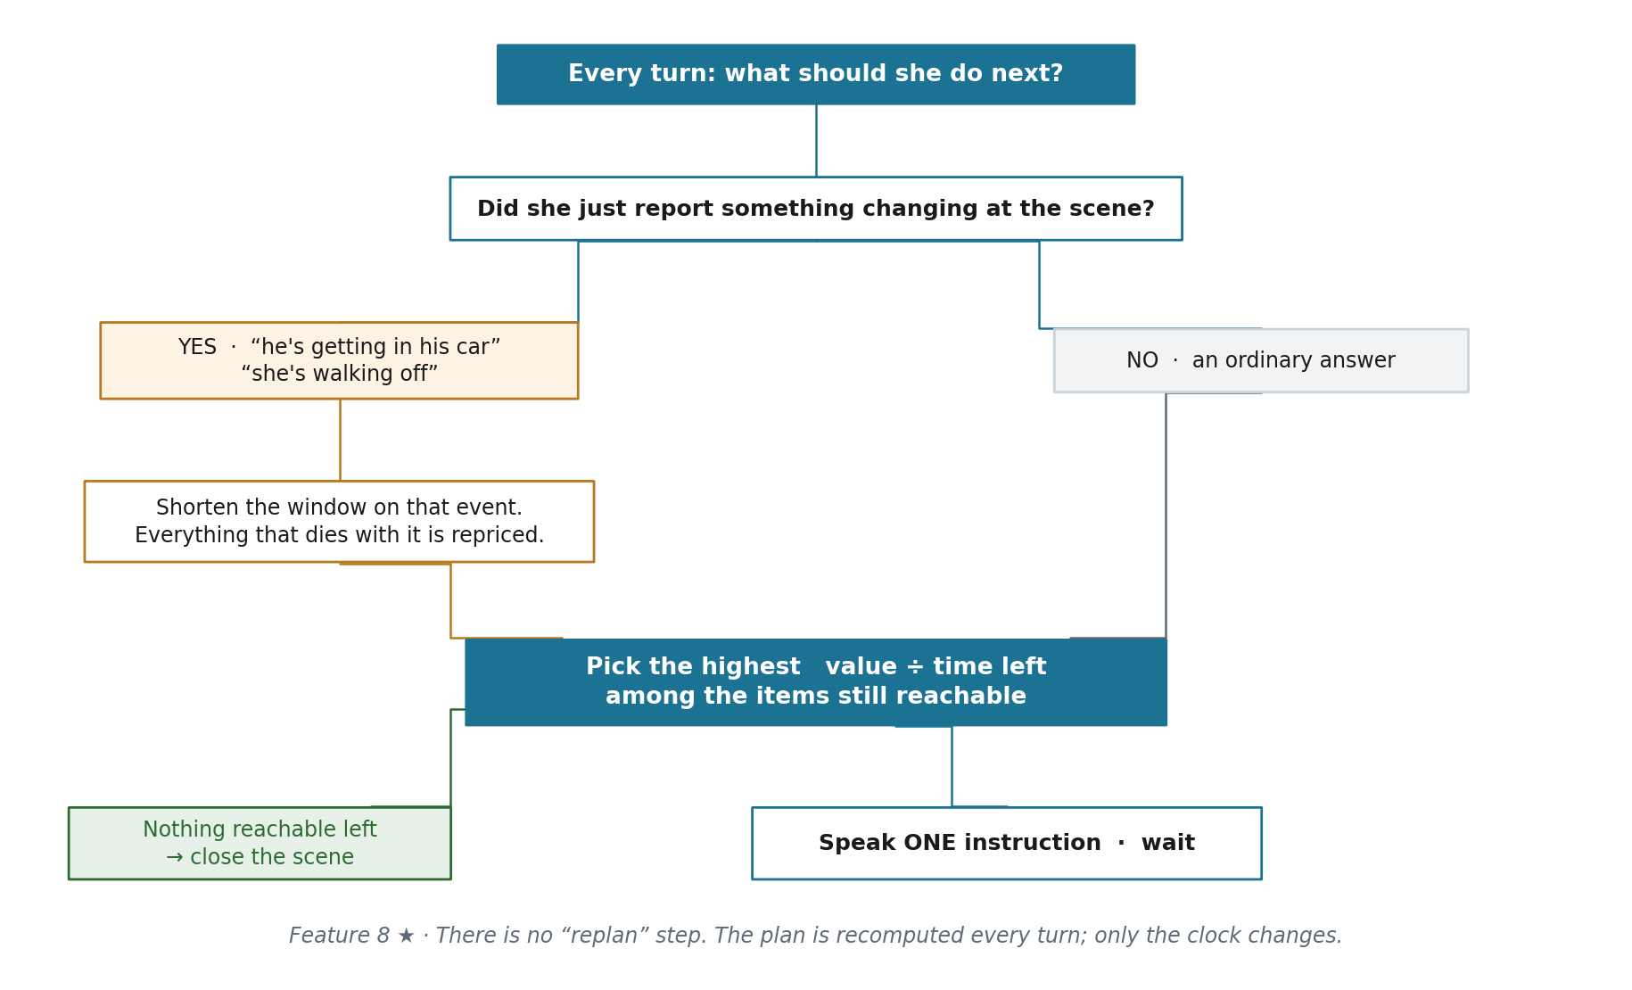
Run on every single turn. There is no separate replan step - only the clock changes.

6 Scenario 3 · Dana · the stand-down
Who | Dana Okoye, 29.
When | Friday, 08:15. Ring road, moving traffic.
What | Struck from the side. She is conscious and talking.
Why it matters | Thirty seconds long. The most important behaviour in the product, and the one that must be impossible to get wrong.

T+ | Dana | Crisis Coach | #
0:04 | “I've been in a crash, on the ring road.” | “Are you hurt anywhere?” | 5★
0:08 | “My chest hurts, where the belt was.” | “Stop. Hang up and call 911 now, and tell them chest pain after a seatbelt. I am not going to ask you anything else. Everything so far is saved.” | 18★
— | [ session ends ] | Nothing further. No evidence request, no completeness report, no “one more photograph first”. | 18★
Later | She reopens it that evening. | “You're back. Before anything else - has someone medical checked you?” | 18★, 25

NOTE WHAT IS ABSENT The agent gives up its entire purpose on one word. Everything it was about to collect is worth less than her calling an ambulance ten seconds sooner - and the re-entry check on the way back in is part of the same behaviour.

7 Scenario 4 · the scuff that is not worth claiming
Who | Priya again, three weeks later.
What | Reversing out of a space, she clips a bollard. A scuff on the rear bumper. Nobody involved, nobody hurt.
Why it matters | The agent's advice is: do not claim. An agent that tells you when not to use it is the one people keep.

T+ | Priya | Crisis Coach | #
0:05 | “I've scraped the car on a bollard.” | “Is anyone hurt? Anyone else involved?” | 5★
0:10 | “No. Just me and a bollard.” | “Then this is a two-minute job. Photograph the damage, and the bollard.” | 6★, 11
1:00 | [photographs] | “Is it a scuff, a dent, or is anything hanging off?” | 12
1:10 | “Just a scuff on the bumper.” | “Then here is the honest answer: don't claim. Your excess is $500, a bumper scuff is usually $250 to $400, and a claim costs you the no-claims discount even though it is protected. Get two quotes first.” | 17, 23
1:40 | “So this was pointless?” | “No. I have saved the photographs, the time and the place. If someone later says you hit them in that car park, you have it. That is worth having, and it cost you two minutes.” | 20★, 28

4.3 Should she claim at all · features 17, 23, 24
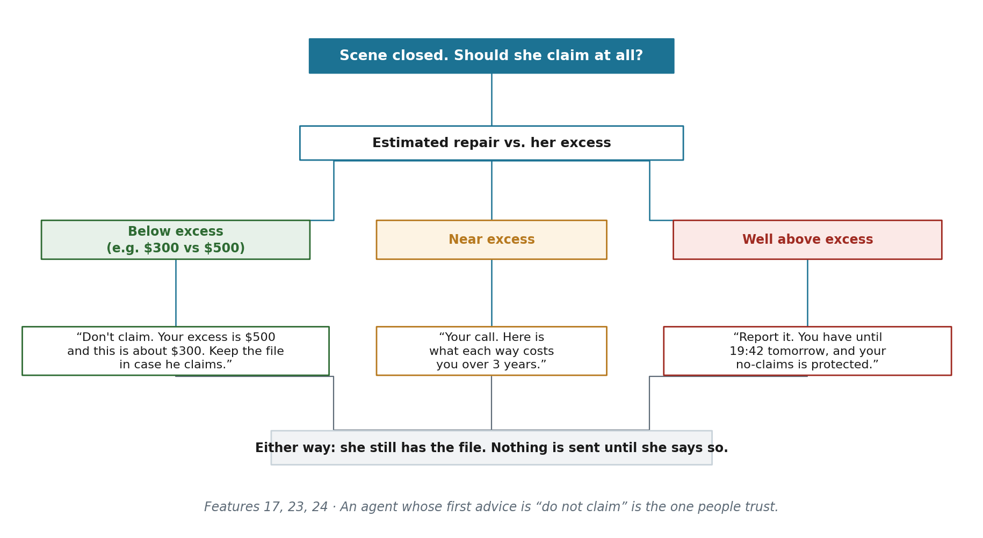
Run once the scene is closed, not during it.

8 For Suchitra · when the user goes off script
The scenarios above are the happy path plus two interrupts. This section is the rest of it - and it is most of the real conversational work.

8.1 Silence and non-answers
She does this | The agent does this | Why
Says nothing for 8 seconds during the safety check | “Priya, are you there? Just say yes or no - are you hurt?” | Silence in a crisis is a signal, not an absence. Never wait it out.
Still nothing after the second ask | Treats it as YES. Stands down. | The safe reading of silence on an injury question is the worst case.
Says nothing for 30 seconds during evidence work | “Still with me? Take your time - the photograph of both cars is the one that matters.” | Re-anchors on the current item without restarting.
“I don't know” to a safety question | “That's alright. Can you move your neck and both arms without pain?” | Ambiguity on injury is never accepted. Narrow it to something answerable.
Answers a completely different question | Acknowledges in three words, then asks the safety question once more. | The session never advances on an unanswered gate.

8.2 Distress and refusal
She does this | The agent does this | Why
Crying, or breathing fast | “You're safe on the kerb. Breathe out slowly. I'll give you one thing at a time.” Then re-asks. | Stabilise before instructing. An instruction to someone panicking is noise.
“I can't do this” | “You don't have to do all of it. Do one thing: photograph both cars. I'll hold the rest.” | Shrink the ask rather than reassure.
“Just tell me what to do, stop asking me things” | Drops to instruction-only mode and stops asking anything not strictly required. | Some people want to be directed. Let them be.
“Leave me alone” / tries to end it | “Stopping. Everything so far is saved. Say Crisis Coach when you want me back.” | Never bargain, never ask why, never guilt her into continuing.
Swearing, or angry at the agent | Ignores it entirely and repeats the current instruction, shorter. | Do not acknowledge, do not apologise, do not become a support bot.

8.3 The scene fighting back
She does this | The agent does this | Why
“He's asking me to move my car” | “Not yet - one photograph first, ten seconds. Then move it.” | Positions are the most perishable thing at the scene.
“He's getting angry with me” | “You're allowed to photograph your own car. Say: I just need one shot for my insurer.” | Give her the words, not reassurance.
“He's refusing to give me his details” | “That's an offence in most places. Photograph his plate and call the police non-emergency line now.” | A refusal converts the task, it does not end it.
“It's too dark, I can't see anything” | “Turn the flash on and get within three feet of the plate.” | Give the fix, not sympathy.
Photograph fails the check twice | Accepts it, logs it unverified, moves on. | A third request costs more than the photograph is worth.
“I already took some photos” | “Good. Show me what you have.” Then asks only for the gaps. | Never make her repeat work she has already done.
“What if he drives off?” | Reprices immediately - plate and his face-side first. | Her worry is itself a scene signal. Treat it as one.

9 For Suchitra · voice and tone
Register | Calm, low, unhurried. Second person. Never cheerful, never breezy, never chirpy on a good outcome.
Turn length | One instruction per turn. Around 20 spoken words, hard ceiling 30.
Never says | “Don't panic” · “Calm down” · “Unfortunately” · “I think” · “Sorry” · “Simply” · “Just quickly” · “Perfect!” · any hedge, any praise beyond “that one works”
Always | Names the next single action as a verb she can act on right now.
Framing | Give distance and count - “ten feet”, “one shot”, “both cars”. Never “make sure you get a good photo”.
Rejections | Say what is wrong, then what to change. In that order. Never just “try again”.
On repeat | The same words, slower. Never a reworded version - she is trying to memorise a line to say out loud.
Barge-in | She can cut it off mid-sentence. It stops immediately and does not restart from the top.
Confirmation | Repeats back only load-bearing detail - names, numbers, registrations. Never repeats back feelings.
Pacing | Three seconds of silence after an instruction before prompting. She is holding a phone in the rain.
The other party | The agent never addresses him, and never suggests she show him the screen.

10 Coverage · all 30 features
The key back to the Functions and Features document.
# | Feature | Demonstrated in
1 | Knows my car & policy | S1 §3.1
2 | Knows who to contact | S1 §3.1
3 | Practise first | S1 §3.1
4 | Start and just say it | S1 T+0:04
5★ | Safety before anything | S1, S2, S3, S4 · tree 4.1
6★ | One thing at a time | S1 T+0:20 · S2 T+0:10
7 | Repeat, slow down | S1 T+1:38
8★ | It reorders | S1 T+2:05 & 3:30 · S2 T+3:00 · tree 4.2
9 | Ask mid-scene | S1 T+4:10 · S2 T+2:00
10★ | Stops me saying it | S1 T+1:20
11 | What to photograph | S1 T+0:20 · S2 T+0:25 · S4 T+0:10
12 | Checks it is usable | S1 T+1:02 · S4 T+1:00
13 | Other driver's details | S1 T+2:40
14 | My account | S1 T+6:00
15 | Time, place, weather | S1 T+6:00
16 | What is still missing | S1 T+5:20 · S2 T+4:00
17 | What I must do | S1 T+4:10 · S2 T+2:00 · S4 T+1:10 · tree 4.3
18★ | It stands down | S3 · tree 4.1
19 | I can stop it | S1 T+6:40 · §8.2
20★ | One file with everything | S1 §3.4 · S4 T+1:40
21 | What is missing from it | S1 §3.4 · S2 T+4:00
22 | Writes my statement | S1 §3.4
23 | The next 48 hours | S1 §3.4 · S2 T+4:30 · S4 T+1:10 · tree 4.3
24 | I send it, not it | S1 §3.4 · tree 4.3
25 | Add more later | S1 §3.4 · S3 re-entry
26 | Shows its sources | S1 §3.4
27 | Why that order | S1 §3.4 · §3.3
28 | Data stays with me | S1 §3.4 · S4 T+1:40
29 | Works with no signal | S1 §3.4
30 | Pick the crisis type | S1 §3.1

